**McNeese State University Field Biology Experience**

**2024 Application**

**Program Dates: June 8 - 26, 2025**

**Name Age**

**Gender (Circle one) M/F/Other**

**High School**

**City/State of School**

**Current Classification (Circle one) Freshman/Sophomore/Junior/Senior**

**Home Address**

**State Zip Code Phone Number**

**Email address**

**Emergency Contact: Name**

**Email**

**Phone number**

**Special dietary restrictions/food allergies**

**Medications**

**HOLD-HARMLESS AGREEMENT**

**I hereby release the State of Louisiana, all State Departments, Agencies, Boards and Commissions, and their respective officers, employees, agents, or representatives from any and all liability, claims, cost, expenses, injuries, illness, or loss resulting from, in whole or part, including attorney fees, for my participation in McNeese State University High School Field Biology Experience on during June of 2024.**

**Recognizing every activity has a certain degree of risk, some more than others, I knowingly and voluntarily assume the risk of these injuries, regardless of severity, which from time to time occur as a result of participation in Field Biology camp experience. Further, as a condition of my participation, I attest that I have medical insurance coverage provided by _______________________________________, a duly licensed provider of health care insurance.**

**If an emergency medical situation arises, I, the undersigned, give consent to the University to seek emergency medical treatment which could incur costs to the participant and their parents.**

**I, the undersigned, am at least eighteen (18) years of age and have read this release form and understand all its terms. If I, the undersigned, am under the age of eighteen (18) years, in addition to my signature, my parent or legal guardian also shall state their having read, signed, and understand this release form and all its terms.**

**________________ ______________________________________________**

**Date Participant (over 18 years of age)**

**_____________________________________________**

**Date Parent of Guardian**

**(Signature required if participant is less than 18)**

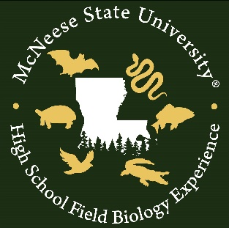 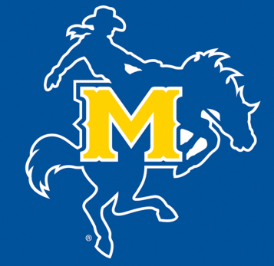

**I hereby grant McNeese State University permission to interview my student participant in the McNeese High School Field Biology Experience Program and/or to use my likeness in photograph(s)/video in any and all of its publications and in any and all other media, whether now known or hereafter existing, controlled by McNeese State University, in perpetuity and for other use by the University. I will make no monetary or other claims against McNeese State University or the McNeese High School Field Biology Program for the use of the interview and/or the photograph(s)/video and I hereby waive my right to inspect and/or approve the finished photograph(s)/video.**

**Guardian name (print) name of student (print)**

**Guardian signature date**

**Applications are due by Friday, April 12, 2025. Please print, fill, scan, and send this application to:**

**Dr. Mark Merchant,** [**drmerchant@mcneesefieldbiology.com**](mailto:drmerchant@mcneesefieldbiology.com) **with APPLICATION in the subject line**

**For questions, please contact Dr. Mark Merchant at** [**drmerchant@mcneesefieldbiology.com**](mailto:drmerchant@mcneesefieldbiology.com)**.**